**Database creation, Table Creation and Data Insertion**

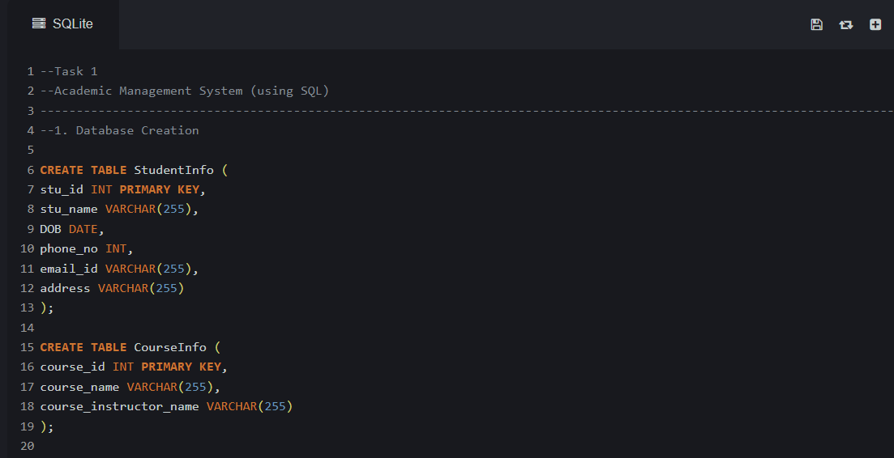

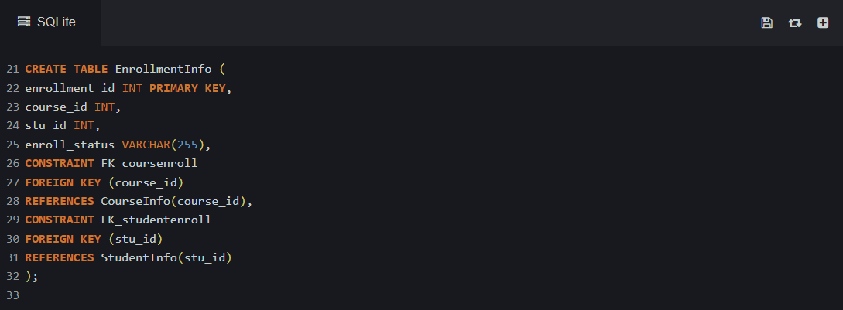

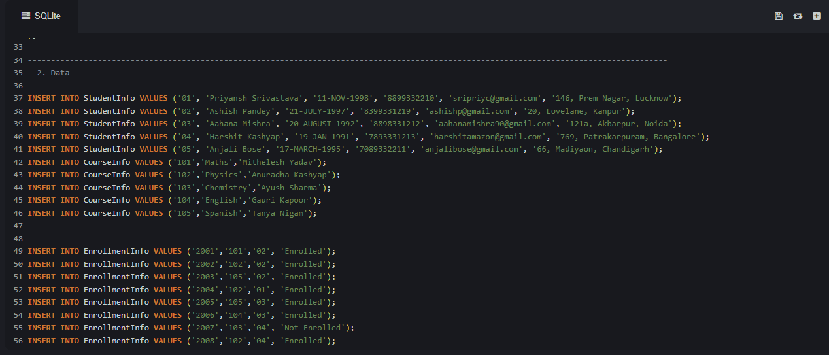

**3a. Write a query to retrieve student details, such as student name, contact information’s, and Enrollment status.**

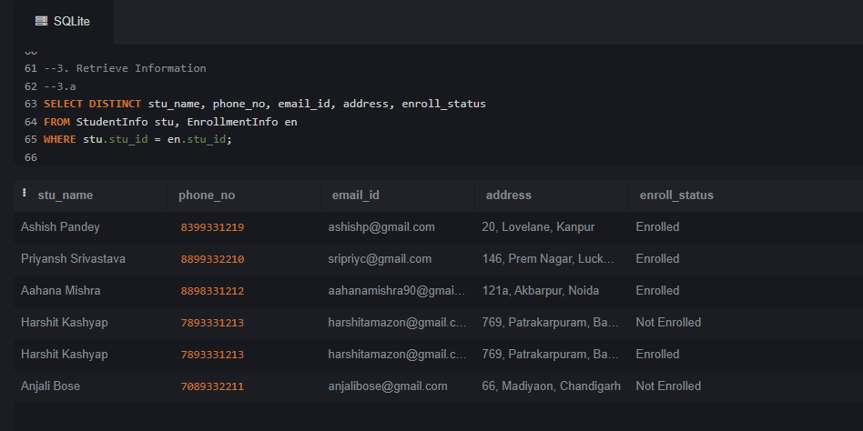

**3b. Write a query to retrieve a list of courses in which a specific student is enrolled.**

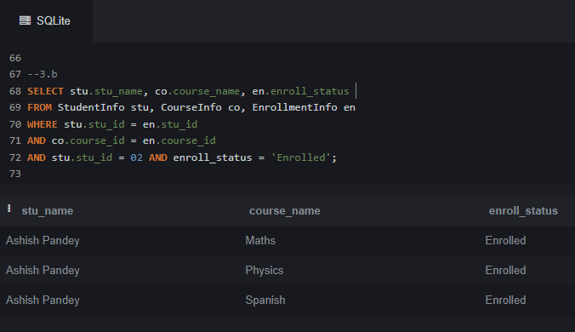

**3c. Write a query to retrieve course information, including course name, instructor information.**

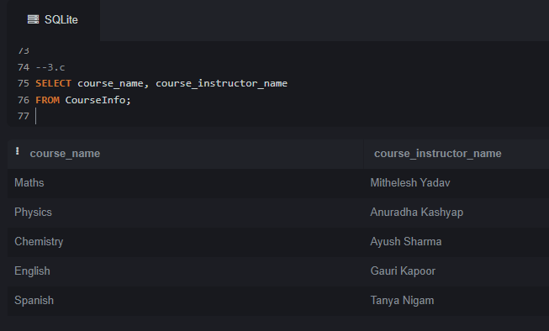

**3d. Write a query to retrieve course information for a specific course.**

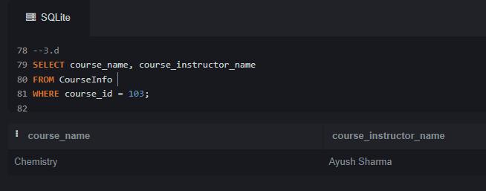

**3e. Write a query to retrieve course information for multiple courses.**

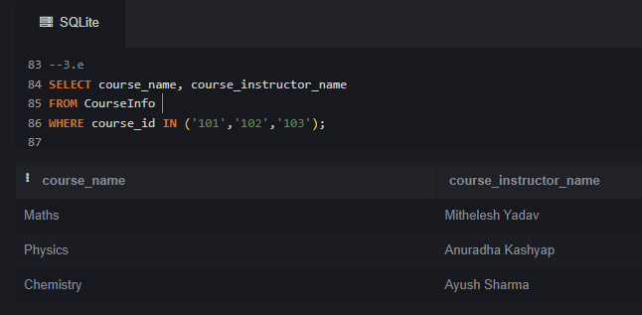

**4a. Write a query to retrieve the number of students enrolled in each course.**

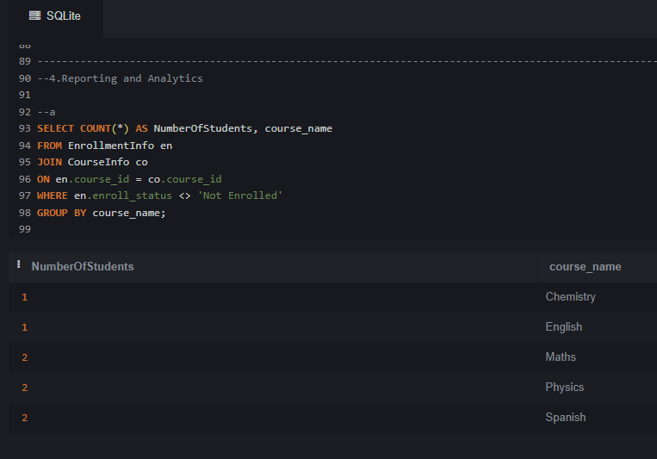

**4b. Write a query to retrieve the list of students enrolled in a specific course.**

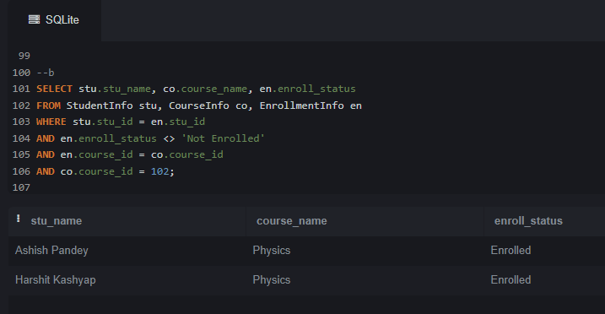

**4c. Write a query to retrieve the count of enrolled students for each instructor.**

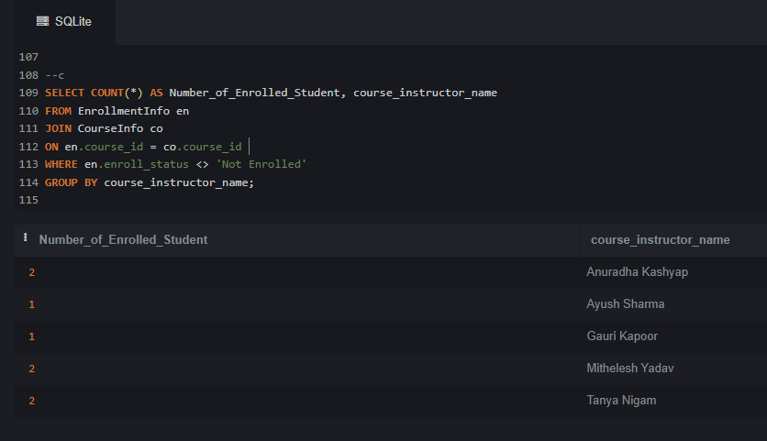

**4d. Write a query to retrieve the list of students who are enrolled in multiple courses.**

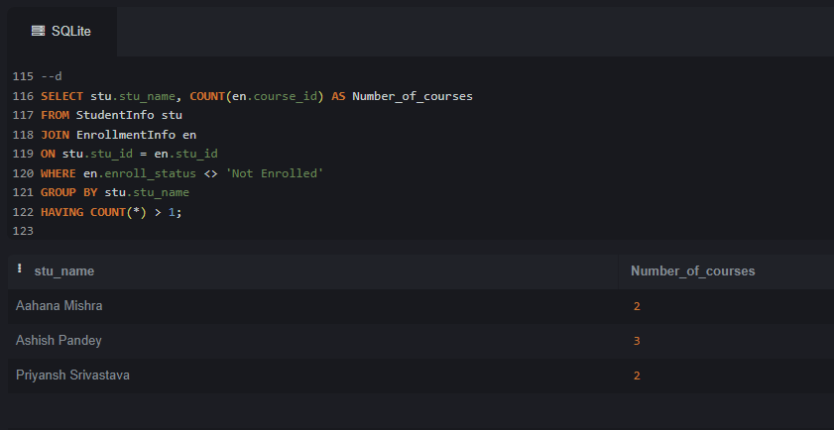

**4e. Write a query to retrieve the list of students who are enrolled in multiple courses.**

